Project: Magnetic Breaking

**Wikipedia** - <https://en.wikipedia.org/wiki/Eddy_current_brake>

Eddy Current Brake

* Dissipates kinetic energy as heat in order to slow or stop a moving object
* Differs from friction brakes as retarding force is caused by electromagnetism and not friction
* The force between a magnet and the conductive moving object is due to eddy currents induced in the conductor through electromagnetic induction
* Benefit: no brake pad wearing as brake does not work by friction
* Cons: No holding force so in vehicles, must be supplemented by a friction brake

Theory

* A conductive surface, usually copper or aluminium (not ferromagnetic such as iron or steel), moving past a stationary magnet gets a circular electric currents induced in the surface, called eddy currents
* Described by Faraday’s law of induction: $emf= -\frac{dΦ}{dt}$. Where *Φ* is the magnetic flux and *t* is time
* The currents create a magnetic field that opposes the field of the magnet (Lenz’s Law)
* The drag force from the magnet on the conductor opposes the motion of the conductor and is proportional to its velocity
* Kinetic energy dissipated as heat generated in the current through electric resistance
* Magnetic field can be created by a permanent magnetic or an electromagnet. However, braking force can be regulated in electromagnet by varying the electric current
* Braking force is proportional to velocity, v, so acts similar to viscous friction in a liquid. Force decreases as velocity decreases. This explains no holding force
* Also demonstrated by dropping a magnet down a non-ferrous pipe. It will decelerate
* Disk brake passes repeatedly through the magnetic field so will got hotter than a linear brake

Uses

* High-speed trains and roller coasters
* Stop power tools quickly
* Electric meters

Mechanisms

Explanation 1

Metal sheet, C, moves to the right under a magnet. The magnetic field (B, green arrows) changes because the sheet is moving. The left side gets closer to magnet and as a result B increases. Faraday’s law of induction tells us that a counter clockwise flow of electric current (I, red) is induced in the sheet. At the right side, the magnetic field decreases and a clockwise eddy current is induced.

Explanation 2

Free charge carriers (electrons) are moving to the right with velocity, v. The magnetic field exerts a sideways force on them (Lorentz force: $F=qv×B$). From the right hand rule, force is towards the rear (to the left when facing in the direction of motion). This creates a current, clockwise to the right and anticlockwise to the left. Electrons have a negative charge so actually flow opposite direction to conventional current. Due to Ampere’s circuital law, these circular currents create a counter magnetic field (blue arrows) which (due to Lenz’s law) oppose the change in magnetic field, causing a drag force. Kinetic Energy is dissipated as heat

**MagCraft** - <https://www.magcraft.com/blog/what-are-eddy-currents>

The size of the eddy current is proportional to the size of the magnetic field, the area of the loop and the rate of change of magnetic flux, and inversely proportional to the resistivity of the conductor.

To reduce the heating effect, laminate the conductive material and insulate each sheet. As shown below:

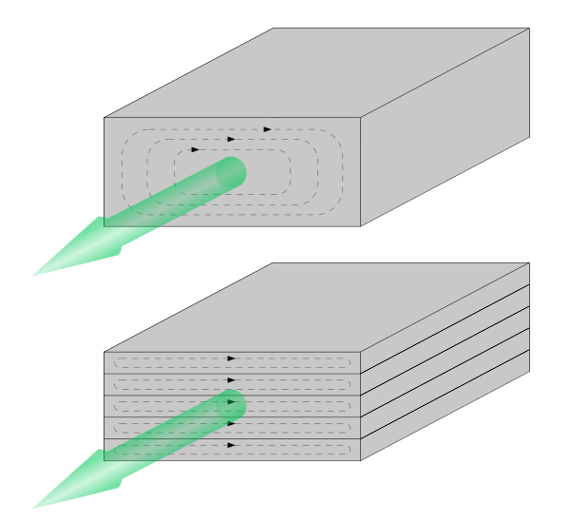

Eddy currents can be removed by cracks or slits in the conductor, breaking the circuit. Therefore, eddy currents can be used to detect defects in materials.

Eddy currents can also be used for magnetic levitation

**Explainthatstuff** - <https://www.explainthatstuff.com/eddy-current-brakes.html>

The magnetic field created by eddy currents oppose whatever causes the eddy currents

As the front part of the train approached the magnet, eddy currents in that bit of the copper would try to generate a repulsive magnetic field (to slow down the copper's approach to the magnet). As the front part passed by, slowing down, the currents would start generating an attractive magnetic field that tried to pull the train back again (again, slowing it down).